Name: ____________________________ Surname: ____________________________ N^{ber}: ____ Grade/Class: _____
Assessment: _____________________________ | Date: ___________________________________________________
 | Teacher’s signature:  ___________________________ | Parent’s signature:  ___________________________

- Read and match.
I like green hats and yellow stars. I like brown guitars.
I like my red dress, and I like pink, blue and yellow baloons.

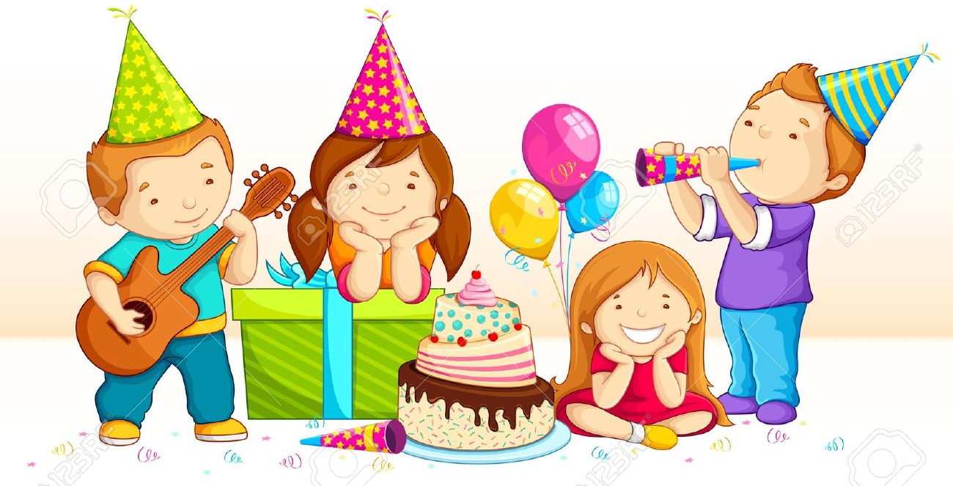
I like purple and I like blue hats.
I like pink hats and yellow stars.I like green boxes.

Answer Key

- Read and match.
I like green hats and yellow stars. I like brown guitars.
I like my red dress, and I like pink, blue and yellow baloons.

I like purple and I like blue hats.
I like pink hats and yellow stars.I like green boxes.

