Name: ____________________________ Surname: ____________________________ N^{ber}: ____ Grade/Class: _____
Assessment: _____________________________ | Date: ___________________________________________________
 | Teacher’s signature:  ___________________________ | Parent’s signature:  ___________________________

- Look at the picture, read and write TRUE or FALSE.

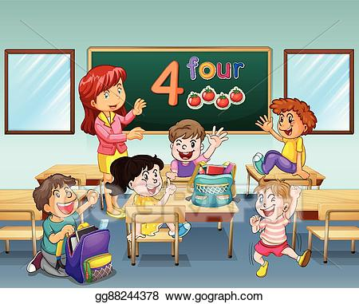

There is... There are...
one green board ________ seven brown desks _______
one blue mirror ________ five students ________
one blue bag ________ three purple bags ________
one tomato ________ four boys ________
one teacher ________ six girls ________

ANSWER KEY
Tehere is... There are...
one green board TRUE seven brown desks FALSE
one blue mirror FALSE five students TRUE
one blue bag TRUE three purple bags FALSE
one tomato FALSE four boys TRUE
one teacher TRUE six girls FALSE

