Name: ____________________________ Surname: ____________________________ N^{ber}: ____ Grade/Class: _____
Assessment: _____________________________ | Date: ___________________________________________________
 | Teacher’s signature:  ___________________________ | Parent’s signature:  ___________________________

- Match.

It is white.
They are red.
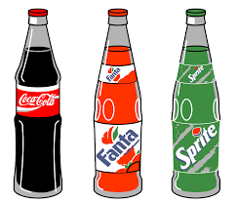
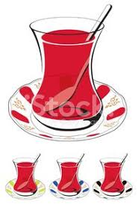
It is brown
It is pink.
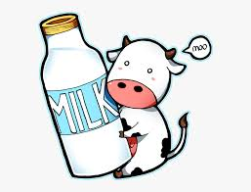
They are black, orange and green.

Answer key
- Match.

It is white.
They are red.
It is brown
It is pink.
They are black, orange and green.

