Name: ____________________________ Surname: ____________________________ N^{ber}: ____ Grade/Class: _____
Assessment: _____________________________ | Date: ___________________________________________________
 | Teacher’s signature:  ___________________________ | Parent’s signature:  ___________________________

- Read and paint the numbers.

Three – pink five – red ten – blue eight – brown six – grey Nine – green one – yellow four – orange two - black ten - white

- Write the number and paint.

________(purple) _________(yellow) _________(blue) _________(orange) _________(brown)

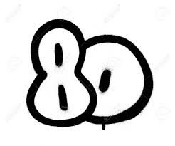
_________(green) _________(red) _________(black) _________(pink)
Answer key
2. Twenty – thırty – forty – fifty – sixty – seventy – eighty – ninety – one hundred

