Name: ____________________________ Surname: ____________________________ N^{ber}: ____ Grade/Class: _____
Assessment: _____________________________ | Date: ___________________________________________________
 | Teacher’s signature:  ___________________________ | Parent’s signature:  ___________________________

- Choose.

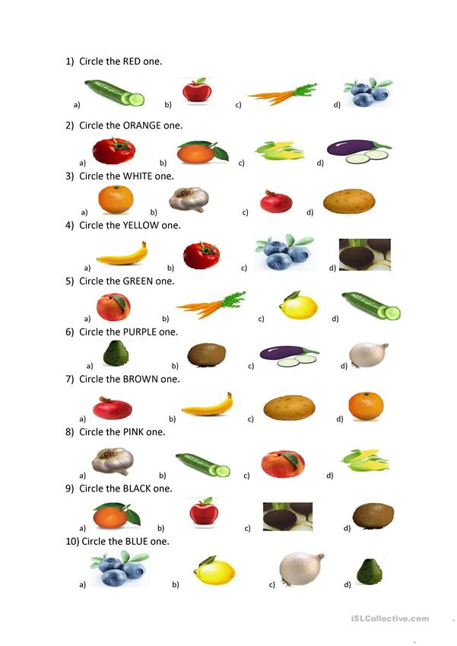
Answer key
1. b
2. b
3. b
4. a
5. d
6. c
7. c
8. c
9. c
10. a

