Name: ____________________________ Surname: ____________________________ N^{ber}: ____ Grade/Class: _____
Assessment: _____________________________ | Date: ___________________________________________________
 | Teacher’s signature:  ___________________________ | Parent’s signature:  ___________________________

- Write or answer the questions.

What color is your desk?
_____________________
What color is the board?
_____________________
What color is the sun?
_____________________
What color is the sky?
_____________________
What color are the trees?
_____________________
What color are the clouds?
___________________________
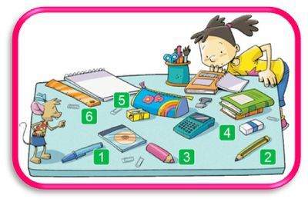

How many notebooks are there?
_____________________
What color is the pencil? (No:3)
_____________________
What color is the pencil sharpener?
_____________________
How many erasers are there?
_____________________
How many pencil cases are there?
_____________________
What color is the pen?
______________________
Answer key
What color is your desk?
Answers may vary
What color is the board?
Answers may vary
What color is the sun?
It’s yellow.
What color is the sky?
It’s blue.
What color are the trees?
They are green.
What color are the clouds?
They are white.
How many notebooks are there?
There are two notebooks.
What color is the pencil? (No:3)
It’s pink.
What color is the pencil sharpener?
It’s yellow.
How many erasers are there?
There is one eraser.
How many pencil cases are there?
There is one pencil case.
What color is the pen?
It’s blue.

