Name: ____________________________ Surname: ____________________________ N^{ber}: ____ Grade/Class: _____
Assessment: _____________________________ | Date: ___________________________________________________
 | Teacher’s signature:  ___________________________ | Parent’s signature:  ___________________________
Look and write
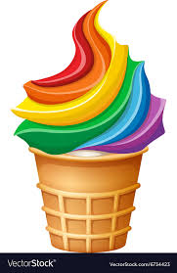 There are .......PURPLE........ berries in the ice cream 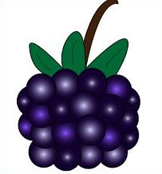
.....................................................strawberries in the ice cream 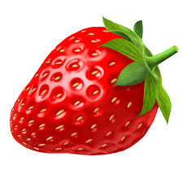
....................................................... bananas in the ice cream 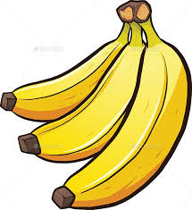
........................................................ lemons in the ice cream 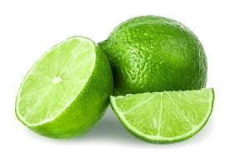
........................................................ chocolate in the ice cream 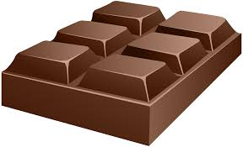
..........................................................cherries in the ice cream 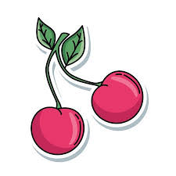

Answer key
There are red strawberries in the ice cream.
There are yellow bananas in the ice cream.
There are green lemon in the ice cream.
There are / is brown chocolate/s in the ice cream.
There are pink cherries in the ice cream.

