Name: ____________________________ Surname: ____________________________ N^{ber}: ____ Grade/Class: _____
Assessment: _____________________________ | Date: ___________________________________________________
 | Teacher’s signature:  ___________________________ | Parent’s signature:  ___________________________
- Look at the picture and answer the questions.
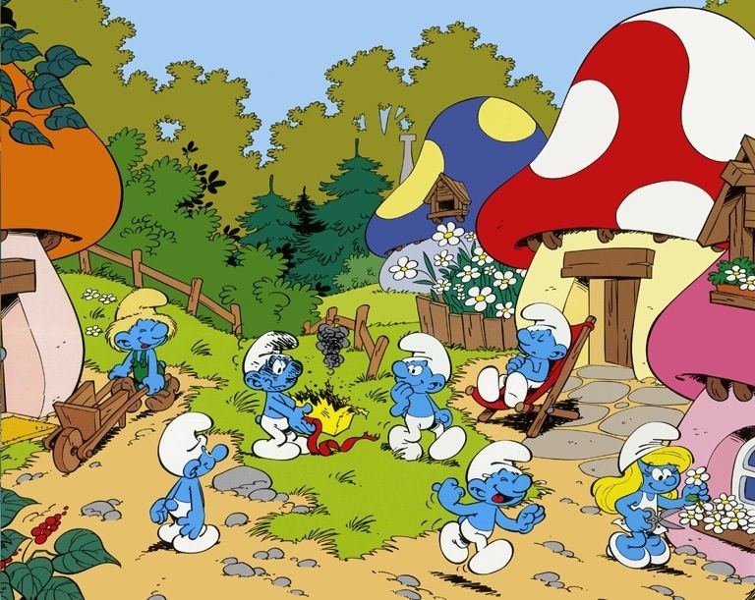

- How many smurfs are there?
_____________________________
- What color are the smurfs?
_____________________________
- How many chairs are there?
_____________________________

- What color is the chair?
_____________________________
- How many houses are there?
_____________________________
- What color are the houses?
_____________________________

2. Look at the picture and write 3 things with colors (Example: BLUE SMURFS)
a. ________________________________________
b. ________________________________________
c. ________________________________________
Answer key
- There are seven smurfs
- They are blue.
- There is one chair.
- It is red.
- There are four houses.
- They are pink, white, red, blue, orange and yellow

- White flowers / hat
- Blue sky
- Green grass
- Green trees
- Yellow box......etc

