Name: ____________________________ Surname: ____________________________ N^{ber}: ____ Grade/Class: _____
Assessment: _____________________________ | Date: ___________________________________________________
 | Teacher’s signature:  ___________________________ | Parent’s signature:  ___________________________

- Write the numbers.

- What is in the toyshop? Look and answer.
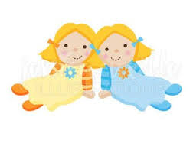 __________________________________________
- ________________________________
- ________________________________
63 dolls 79 robots
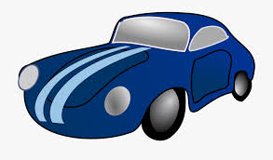
1.__________________________________
2.__________________________________
51 cars 96 crayons
Answer key

5 five
16 sixteen
76 seventy six
40 forty
55 fifty five
68 sixty eight
23 twenty three
87 eighty seven
36 thirty six
14 fourteen
29 twenty nine
65 sixty five
47 forty seven
33 thirty three

There are sixty three dolls in the toyshop.
There are seventy nine robots in the toyshop.
There are fifty one cars in the toyshop.
There are ninety six crayons in the toyshop.

