Name: ____________________________ Surname: ____________________________ N^{ber}: ____ Grade/Class: _____
Assessment: _____________________________ | Date: ___________________________________________________
 | Teacher’s signature:  ___________________________ | Parent’s signature:  ___________________________
- Color the vehicles and then write sentences as in the example.
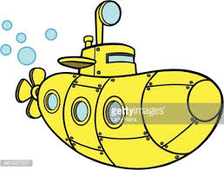
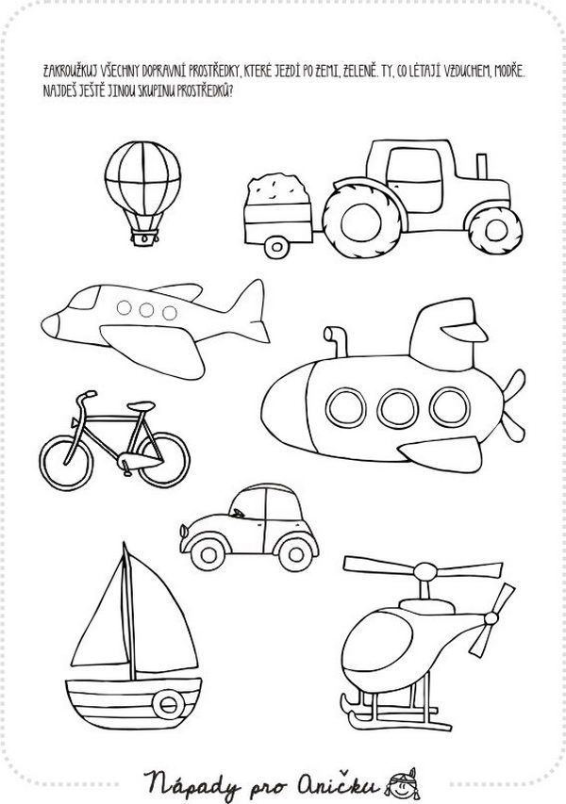

- The submarine is yellow.
WORD BANK
Balloon
Tractor
Plane
Bicycle
Car
Boat
Helicopter

- ..............................................................................................
- ..............................................................................................
- ..............................................................................................
- ..............................................................................................
- ..............................................................................................
- ..............................................................................................
- ..............................................................................................

