Name: ____________________________ Surname: ____________________________ N^{ber}: ____ Grade/Class: _____
Assessment: _____________________________ | Date: ___________________________________________________
 | Teacher’s signature:  ___________________________ | Parent’s signature:  ___________________________

- Listen and match.
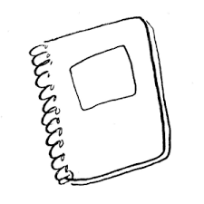

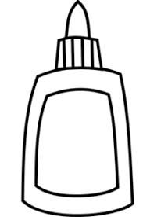

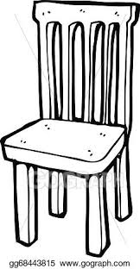
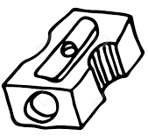
Script

A yellow notebook
An orange dustbin
A pink glue
A grey chair
A blue sharpener

