Name: ____________________________ Surname: ____________________________ N^{ber}: ____ Grade/Class: _____
Assessment: _____________________________ | Date: ___________________________________________________
 | Teacher’s signature:  ___________________________ | Parent’s signature:  ___________________________

- Look and tell.

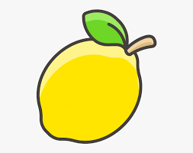
A yellow lemon.

____________________________________________

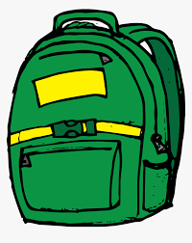

____________________________________________

____________________________________________

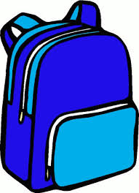

____________________________________________

Answer key
A blue and red eraser
A green bag
orange scissors
a blue bag

