Name: ____________________________ Surname: ____________________________ N^{ber}: ____ Grade/Class: _____
Assessment: _____________________________ | Date: ___________________________________________________
 | Teacher’s signature:  ___________________________ | Parent’s signature:  ___________________________

- Look at the numbers and tell them with colors.

A black one
__________
__________
__________
__________

2. Tell likes & dislikes.

__________
__________
__________
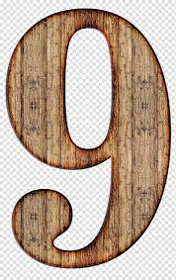 __________
__________

Ex: I like pink.

Answer Key
1.
A yellow two
A blue three
A purple four
A green five
An orange six
A red seven
A grey eight
A brown nine
A white ten
2. Tell likes & dislikes.

I like orange
I like yellow
I like green
I like blue
I like purple
I don’t like red
I don’t like black
I don’t like brown

