Name: ____________________________ Surname: ____________________________ N^{ber}: ____ Grade/Class: _____
Assessment: _____________________________ | Date: ___________________________________________________
 | Teacher’s signature:  ___________________________ | Parent’s signature:  ___________________________

- Look at the pictures, answer the questions.

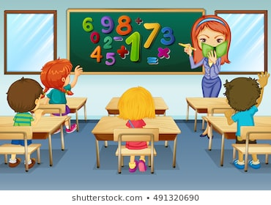

- How many students are there?
__________________________

- What color is the board?
_________________________

- How many girls are there?
_________________________

- What color are the desks?
_________________________

- How many books are there?
_________________________

- What color is the book?
_________________________

Answer Key
1. There are 4 students.
2.The board is green.
3. There are 2 girls
4. The desks are brown
5. There is one book
6. It is green

