 **ENGLISH WORKSHEET** 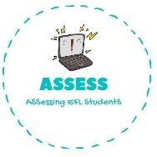

**Colour numbers and write the names under the figures.**

|  |  |  |  |  |
| --- | --- | --- | --- | --- |
|  |  |  |  |  |
|  |  |  |  |  |
|  |  |  |  |  |
|  |  |  |  |  |

|  |  |  |  |  |
| --- | --- | --- | --- | --- |
| **FOURTEEN** | **SEVENTEEN** | **TWELVE** | **TWENTY** | **THIRTEEN** |
| **ELEVEN** | **NINETEEN** | **FIFTEEN** | **EIGHTEEN** | **SIXTEEN** |

|  |  |  |  |  |
| --- | --- | --- | --- | --- |
|  |  |  |  |  |
|  |  |  |  |  |
|  |  |  |  |  |
|  |  |  |  |  |

|  |  |  |  |  |
| --- | --- | --- | --- | --- |
| **SIX** | **THREE** | **TEN** | **EIGHT** | **FOUR** |
| ONE | **FIVE** | **SEVEN** | **TWO** | **NINE** |