Name: ____________________________ Surname: ____________________________ N^{ber}: ____ Grade/Class: _____
Assessment: _____________________________ | Date: ___________________________________________________
 | Teacher’s signature:  ___________________________ | Parent’s signature:  ___________________________

- Look and tell.

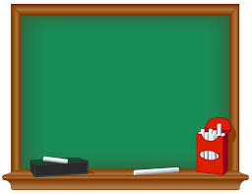
_________________
A green board

_________________
_________________
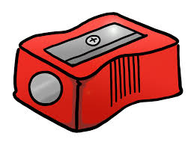
_________________

_______________

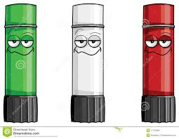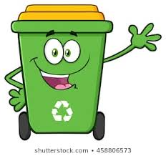
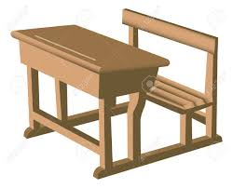
_________________

________________

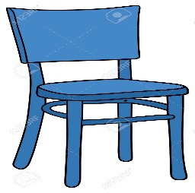
_________________

____________________________________________

Answer key
A purple pen
A red sharpener
A grey computer
Green, white and red glues
A brown desk
A pink notebook
A blue chair
A white ruler

