|  |  |  |
| --- | --- | --- |
| **Name:** ____________________________ **Surname:** ____________________________ **Nber: ____ Grade/Class:** _____ | | |
| **Assessment:** _____________________________ | **Date:** ___________________________________________________ | |
| **Teacher’s signature:**  **___________________________** | **Parent’s signature:**  **___________________________** |

1. **Look and tell your partner the colors and the name of the objects. (Student A)**
2. 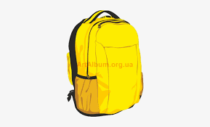 b. 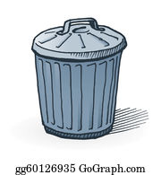 c. 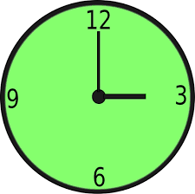

d. 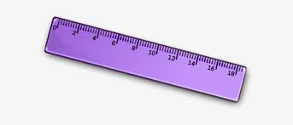 e.  f. 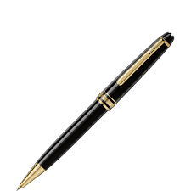

1. **Now listen to your partner and paint the objects.**

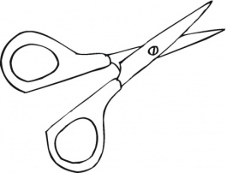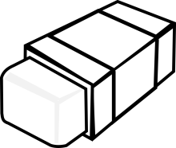

1. **b. c.** 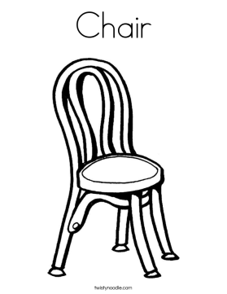

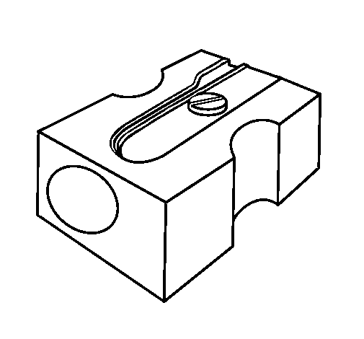**d. 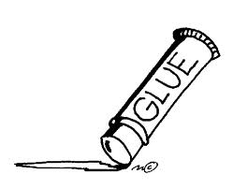 e. f.**

1. **Listen to your partner and paint the objects. (Student B)**
2. 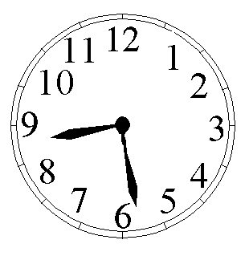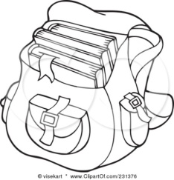 b. 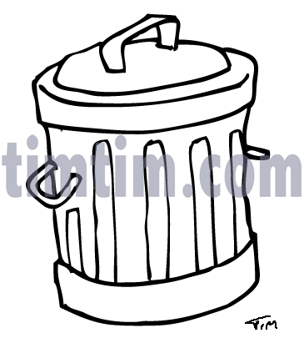 c.

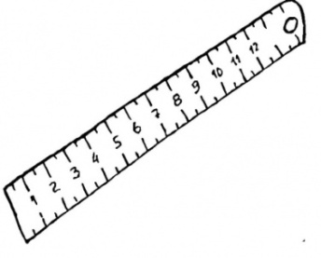

d. e. 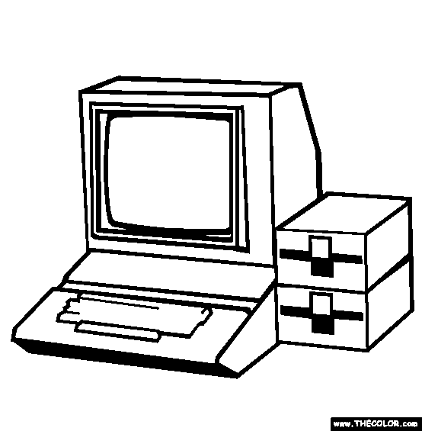 f.

1. **Now, look and tell your partner the colors and the name of the objects.**
2. 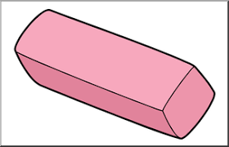 **b.  c.** 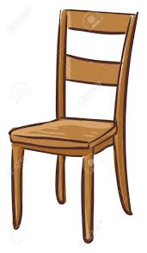

**d. 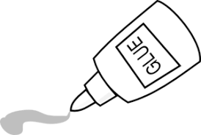 e. 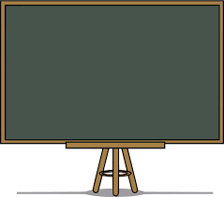 f.** 