Name: ____________________________ Surname: ____________________________ N^{ber}: ____ Grade/Class: _____
Assessment: _____________________________  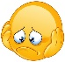  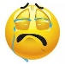 | Date: ___________________________________________________
 | Teacher’s signature:  ___________________________ | Parent’s signature:  ___________________________

- Look at the picture ask the questions to your partner. Then answer your partner’s questions. (Student A)

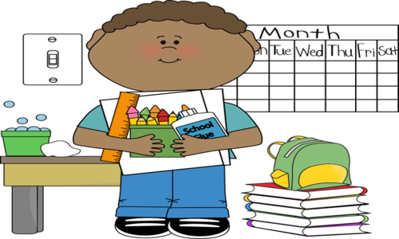

- What color is the desk?
________________________

- What color is the dustbin?
________________________

- What color is the bag?
________________________

- What color is the ruler?
________________________

- What color is the glue?
________________________

- What color are the books?
________________________

- Look at the picture ask the questions to your partner. Then answer your partner’s questions. (Student B)

- How many desks are there?
________________________

- How many dustbins are there?
________________________

- How many bags are there?
________________________

- How many crayons are there?
________________________

- How many balls are there?
________________________

- How many books are there?
________________________

Answer key

Student A
- What color is the desk?
It is brown and grey.

- What color is the dustbin?
It is green.

- What color is the bag?
It is green.

- What color is the ruler?
It is orange.

- What color is the glue?
It is white and blue.

- What color are the books?
They are red, blue, yellow, purple and green.

Student B

- How many desks are there?
There is one desk.

- How many dustbins are there?
There is one dustbin.

- How many bags are there?
There is one bag.

- How many crayons are there?
There are seven crayons.

- How many balls are there?
There are seven balls.

- How many books are there?
There are five books.

