Name: ____________________________ Surname: ____________________________N^{ber}: ____ Grade/Class: _____
Assessment: _____________________________ | Date: ___________________________________________________
 | Teacher’s signature:  ___________________________ | Parent’s signature:  ___________________________

- Listen and circle.
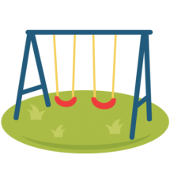
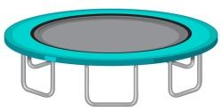
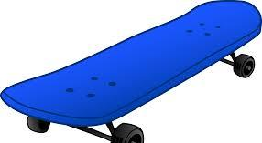

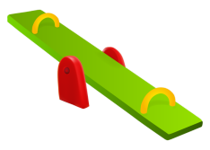
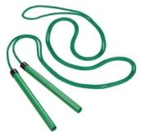

- Listen and Tick.

- Where does Nick want to play with Kelly?

On the see-saw In the sandpit On the monkey bars

- How many friends of Nick are playing in the playground?

8 9 7

- What does Ann do when she feels upset?

Listens to music Reads books Plays in the playground

TRANSCRIPT

EXERCISE 1

Look. There is so much equipment in the playground.

- Skipping rope
- Trampoline
- Seesaw
- Skateboard
- Slide
- Swing

EXERCISE 2

ONE
Mother: Hey Nick! Come let’s go to the playground.
Nick: Mom, Can I play in the sandpit with Kelly today?
Mother: Of course.

TWO
Nick: Kelly, Will you come with me to the playground?
Kelly: No, I have homework to do.
Nick: There are 8 of our friends playing there. Come on. Let’s join them.
Kelly: No, I am right now busy!

THREE
Zoya: Hey Ann! What do you do when you feel upset?
Ann: I go to the playground and play with my friends. What do you do?
Zoya: I listen to calming music or read books sometimes.
Ann: That’s great!

