Name: ____________________________ Surname: ____________________________N^{ber}: ____ Grade/Class: _____
Assessment: _____________________________ | Date: ___________________________________________________
 | Teacher’s signature:  ___________________________ | Parent’s signature:  ___________________________

- Listen and tick.

- Where are they going?
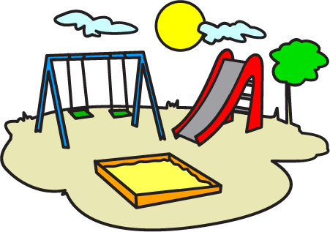
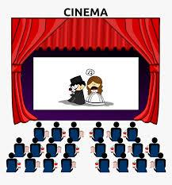

- What do they take three turns at?
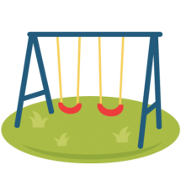
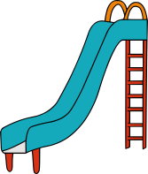
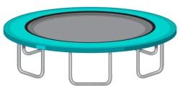

- What do they climb?
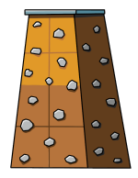
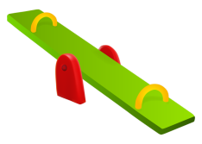

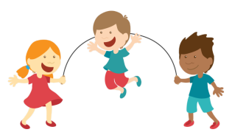
- What do they play with their other friends?
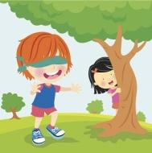

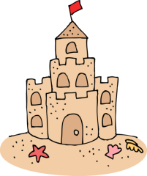
- Where did they build?

TRANSCRIPT

EXERCISE 1

Let’s hear the playground experiences of the two friends – George and Harry!
George and Harry are going to the playground. First, they swing on the swings. Then,they take three turns at the slide. They climb on the climbing wall. They play hide and seek with their other friends. They build a sand castle in the sandbox. They drink water from the water fountain, then they go home.

