Name: ____________________________ Surname: ____________________________N^{ber}: ____ Grade/Class: _____
Assessment: _____________________________ | Date: ___________________________________________________
 | Teacher’s signature:  ___________________________ | Parent’s signature:  ___________________________

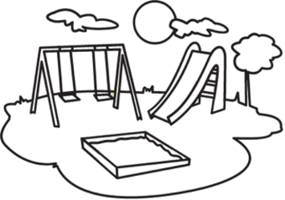
- Listen and colour.

- Listen and tick.

- When does she go to the playground?

On Saturdays On Sundays On Fridays

- Where’s the playground?

In the park In the school In the market

- She plays the slide with ____.

Joseph Mary Ana

- She runs around the park with _____.

Chaya Bruno Jenny

- She plays soccer with ______.

Chaya and Jenny Kelly and Jenny Chaya and Kelly

TRANSCRIPT

EXERCISE 1

Come on! Let’s color the playground.

- Colour the slide red and swing blue.
- Colour the sandpit brown and grass green.
- Colour the sun yellow and clouds white.
- Colour the tree trunk brown and leaves green.
- Colour the sky blue.

EXERCISE 2

Hello! My name is Suzie.
On Sundays, I like to go the playground in the park. I love playing with my friends. I play on the slide with Ana. I run around the park with my pet – Bruno. And I play soccer with Chaya and Jenny.

