Name: ____________________________ Surname: ____________________________N^{ber}: ____ Grade/Class: _____
Assessment: _____________________________ | Date: ___________________________________________________
 | Teacher’s signature:  ___________________________ | Parent’s signature:  ___________________________

- Listen and number.
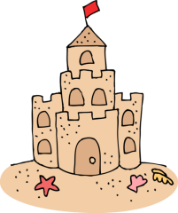

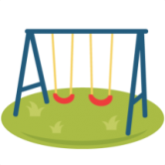
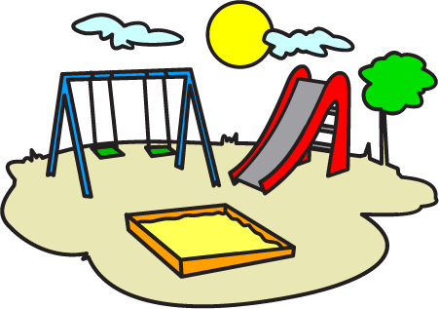
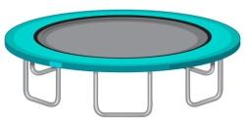

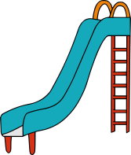
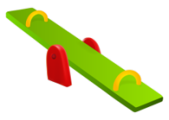
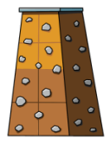
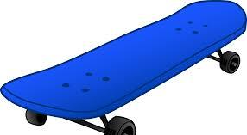

- Listen, link and colour.
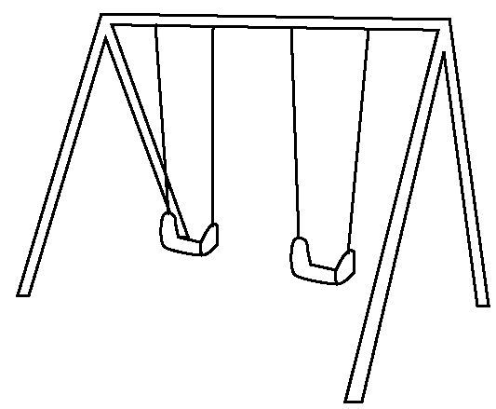
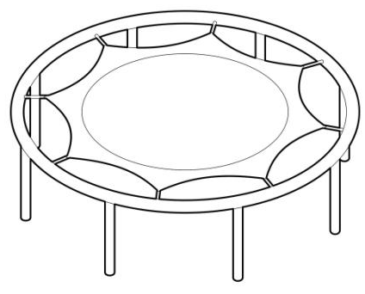

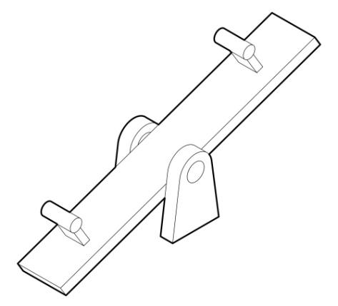
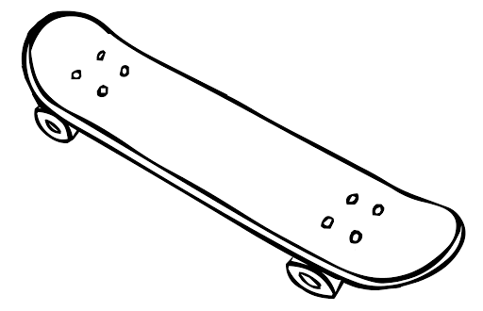

TRANSCRIPT

EXERCISE 1

- Sand castle
- Trampoline
- Skateboard
- Swing
- Slide
- Seesaw
- Climb rock wall
- Playground

EXERCISE 2

Jonny uses these equipment in the playground. Link and color only those equipment.

- Seesaw
- Slide
- Trampoline
- Skateboard

