Name: ____________________________ Surname: ____________________________N^{ber}: ____ Grade/Class: _____
Assessment: _____________________________ | Date: ___________________________________________________
 | Teacher’s signature:  ___________________________ | Parent’s signature:  ___________________________

- Listen and match.
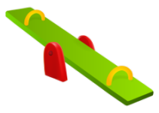
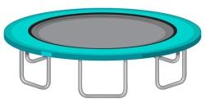
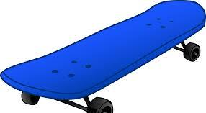

. . . . .

. . . . .

KATE AND CHRISTINE
ROHAN AND RONNIE
JOANNA
RICKY
JOSEPH

- Listen and draw.

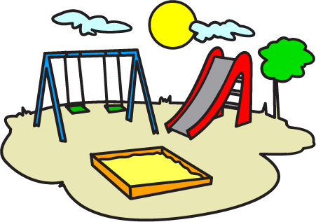

. .

TRANSCRIPT

EXERCISE 1

- Rohan and Ronnie like to play on the swing.
- Joanna likes to jump on the trampoline.
- Ricky likes to skate.
- Kate and Christine love to play on the seesaw.
- Joseph likes to play on the slide.

EXERCISE 2

Let us help Ronnie find the playground!

Teacher: What happened to Ronnie?
Kelly: He is crying because he is not able to find the playground.
Kelly: How can we help him find the playground?
Teacher: Draw a straight line from Ronnie to the playground.
Kelly: Great!

