Name: ____________________________ Surname: ____________________________ N^{ber}: ____ Grade/Class: _____
Assessment: _____________________________ | Date: ___________________________________________________
 | Teacher’s signature:  ___________________________ | Parent’s signature:  ___________________________
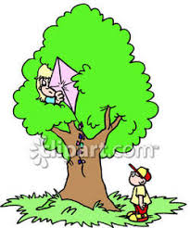
Read the text.
Ivan is in the park. Ivan is under the tree.
The ball is in the net.
The kite is on the tree.
Sally is on the slide.

1) Read and write Yes or No.
- Ivan is in the park.
- The ball is on the tree.
- The kite is in the net.
- Ivan is under the tree.

2) Match.
a) Ivan is I) in the net.
b) The ball is II) on the tree.
c) The kite is III) under the tree.
d) Sally is IV) next to the slide.

Answer key

- Yes; No; No; Yes.
- A-III; b-I; c-II; d-IV

