Name: ____________________________ Surname: ____________________________ N^{ber}: ____ Grade/Class: _____
Assessment: _____________________________  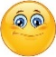 | Date: ___________________________________________________
 | Teacher’s signature:  ___________________________ | Parent’s signature:  ___________________________

- Read and draw.
- The ball is under the seesaw. b) The kite is on the tree.
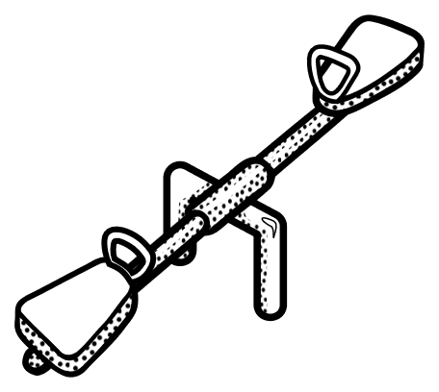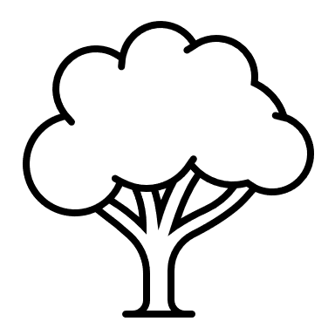

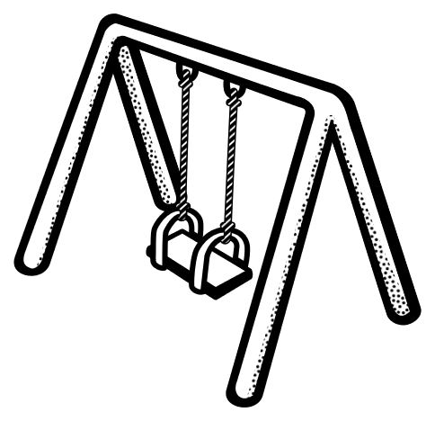
- The ball is in the net. d) The slide is next to the swing.

2) Read and colour the pictures in exercise 1.
a) The kite is red.
b) The seesaw is yellow.
c) The balls are blue.
d) The swing is green.

Answer key
- Drawing
- Colouring

