Name: ____________________________ Surname: ____________________________ N^{ber}: ____ Grade/Class: _____
Assessment: _____________________________  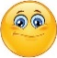 | Date: ___________________________________________________
 | Teacher’s signature:  ___________________________ | Parent’s signature:  ___________________________

Read and choose the best answer. Put a tick.

- You play with a ball.
a) b) c)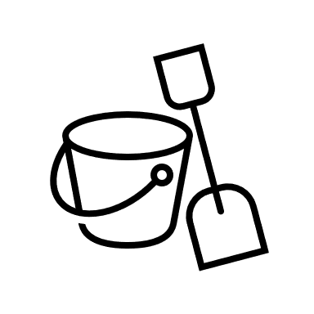

- You fly a kite.
a) b) c)

- You play in the sand.
a) b) c)

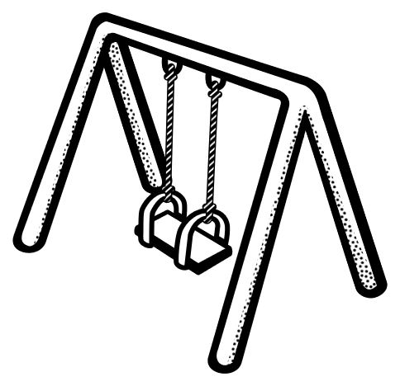
- You are on the swing.
a) 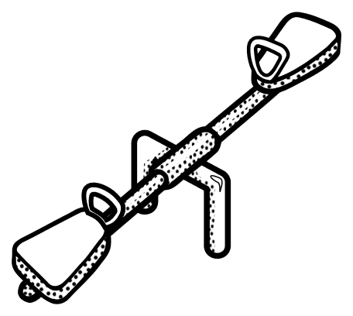 b) c)

- You are on the seesaw.
a) b) c)

Answer key

1. a;
2. b;
3. c;
4. b;
5. a

