Name: ____________________________ Surname: ____________________________ N^{ber}: ____ Grade/Class: _____
Assessment: _____________________________  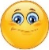 | Date: ___________________________________________________
 | Teacher’s signature:  ___________________________ | Parent’s signature:  ___________________________

- Read, match and write names.
- Martin is on the swing.
- Molly is on the seesaw.
- Hugo is in the sand.
- Ann is under the tree.
- Emily is on the slide.

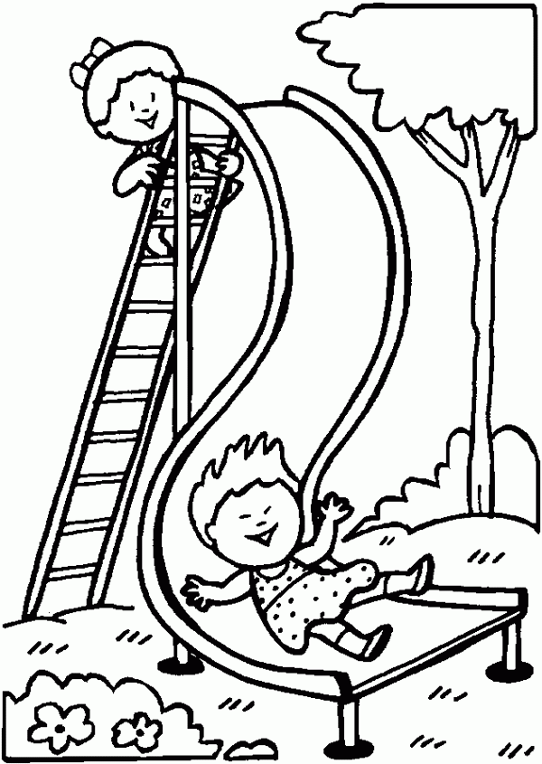
_________

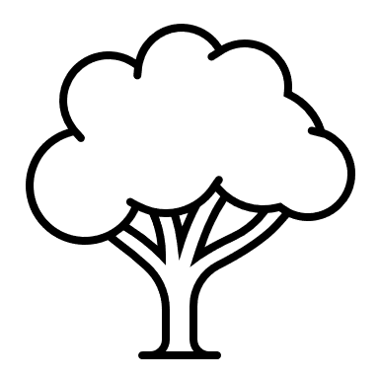
_______

________

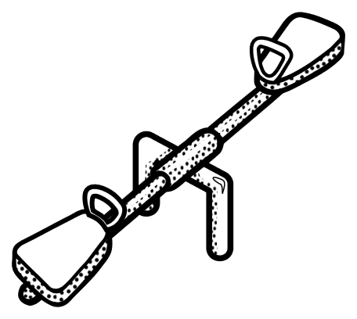
_________

________
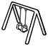

Answer key

Ann
Hugo
Martin
Emily
Molly

