Name: ____________________________ Surname: ____________________________ N^{ber}: ____ Grade/Class: _____
Assessment: _____________________________ | Date: ___________________________________________________
 | Teacher’s signature:  ___________________________ | Parent’s signature:  ___________________________

- Look at the picture and say.

What is there in the picture?
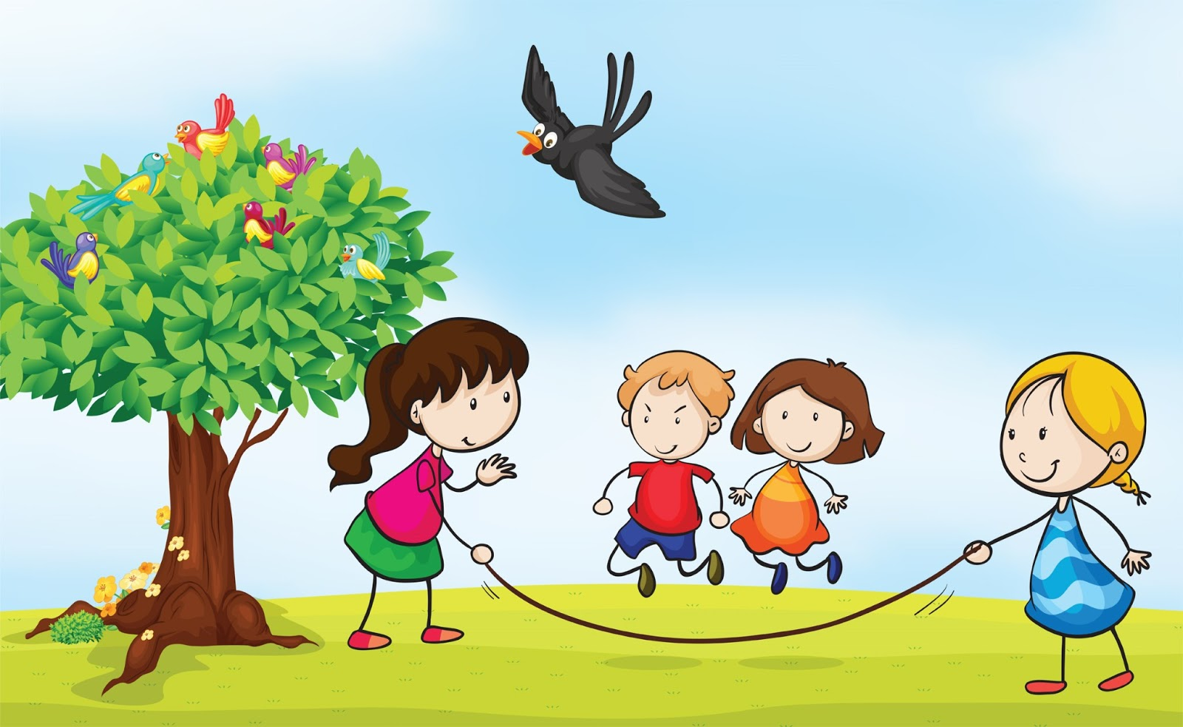

- Look at the picture again and say:
- Where are the flowers?
- Where are the birds?
- How many birds are there on the tree?
- How many children are there?

Answer key

- The children are playing.

- a) The flowers are under the tree.
b) The birds are on the tree.
c) There are six birds on the tree.
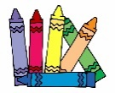
d) There are four children.

