Name: ____________________________ Surname: ____________________________ N^{ber}: ____ Grade/Class: _____
Assessment: _____________________________ | Date: ___________________________________________________
 | Teacher’s signature:  ___________________________ | Parent’s signature:  ___________________________

- Look at the picture and say.

What is there in the picture?

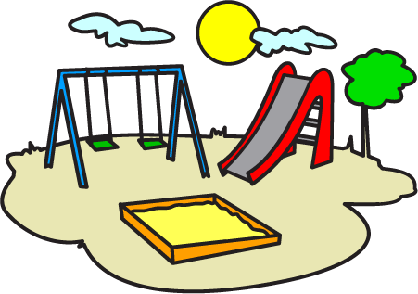

- Look at the picture again and say:
- Where is the tree?
- Where is the sand?
- Where is the slide?
- Are there any children?

Answer key

- There is a slide. There is a swing. There is a tree. There is sand.

- a) The tree is next to the slide.
b) The sand is in front of the swing.
c) The slide is next to the swing.
d) No, there aren’t.

