Name: ____________________________ Surname: ____________________________ N^{ber}: ____ Grade/Class: _____
Assessment: _____________________________ | Date: ___________________________________________________
 | Teacher’s signature:  ___________________________ | Parent’s signature:  ___________________________

- Look at the picture and answer the questions:
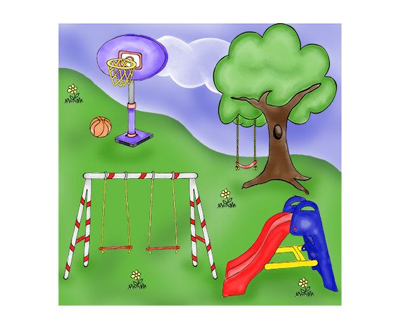
- Where is the ball?
- Where is the slide?
- Where are the flowers?
- Are there any children in the playground?

2. Answer the questions about you.
Do you like to play in the playground?

Answer key

- a) The ball is under the basket.
b) The slide is next to the swing.
c) The flowers are on the grass.
d) No, there aren’t.

- Yes, I do./No. I don’t.

