Name: ____________________________ Surname: ____________________________ N^{ber}: ____ Grade/Class: _____
Assessment: _____________________________ | Date: ___________________________________________________
 | Teacher’s signature:  ___________________________ | Parent’s signature:  ___________________________

- Look at the pictures and say.

Where are the children? What is there in the picture?
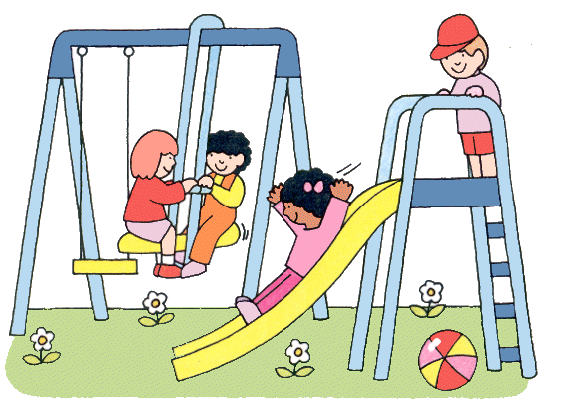

- Look at the picture again and answer the questions.
- Where is the ball?
- Where are the boy and the girl in pink T-shirt?
- Where are the girls?
- Where is the swing?

Answer key

- The children are in the playground. There is a swing and a slide.

- a) The ball is under the slide.
b) They are on the slide.
c) They are on the swing.
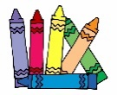
d) The swing is next to the slide.

