Name: ____________________________ Surname: ____________________________ N^{ber}: ____ Grade/Class: _____
Assessment: _____________________________ | Date: ___________________________________________________
 | Teacher’s signature:  ___________________________ | Parent’s signature:  ___________________________

- Look at the picture and answer the questions.
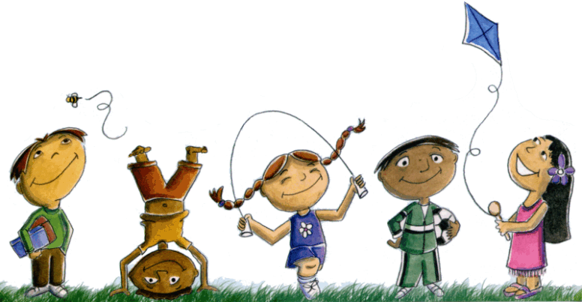

- How many children are there?
- Are there any animals?
- What is the girl in blue dress doing?
- What is the girl in pink dress doing?
- What does the boy in green trousers have?

2. Answer the questions about you.
Do you like to fly a kite? Do you like to play football?

Answer key

- a) There are five children.
b) Yes, there is a bee.
c) She is umping.
d) She is flying a kite.
e) He has a ball.

- Yes, I do/No, I don’t.

