Name: ____________________________ Surname: ____________________________ N^{ber}: ____ Grade/Class: _____
Assessment: _____________________________ | Date: ___________________________________________________
 | Teacher’s signature:  ___________________________ | Parent’s signature:  ___________________________

- Match.

Swings monkey bar seesaw sand pit slide bridge

. 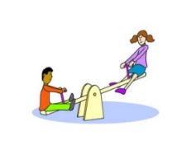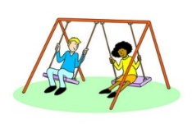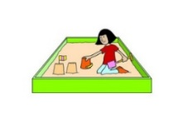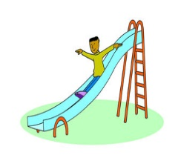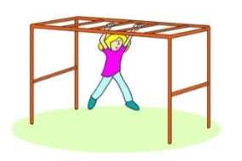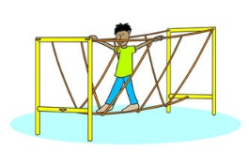

- Find the following words in the crossword.

Swing, slide, dance, run, skip rope, football, playground, jump, walk, sing a song, hide and seek
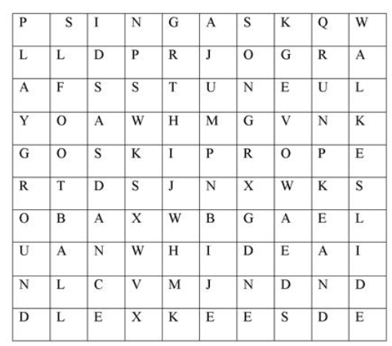

Answer key

- Swings-2, monkey bar -5, seesaw – 1, sand pit -3. Slide -4. Bridge -6.

p | s | i | n | g | a | s |  |  | w
l |  |  |  |  | j | o |  | r | a
a |  | s |  |  | u | n |  | u | l
y |  |  | w |  | m | g |  | n | k
g |  | s | k | i | p | r | o | p | e
r |  | d |  |  | n |  |  |  | s
o |  | a |  |  |  | g |  |  | l
u |  | n |  | h | i | d | e | a | i
n |  | c |  |  |  |  |  | n | d
d |  | e |  | k | e | e | s | d | e

