Name: ____________________________ Surname: ____________________________ N^{ber}: ____ Grade/Class: _____
Assessment: _____________________________  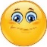  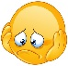  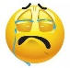 | Date: ___________________________________________________
 | Teacher’s signature:  ___________________________ | Parent’s signature:  ___________________________

1) Fill in the gaps.

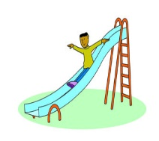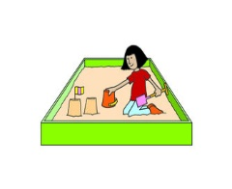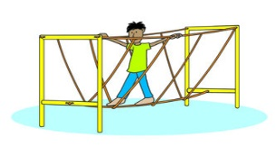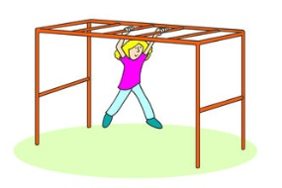

__li __ e sand p__ __ b__ i__ g_ mo__k__ey b__r

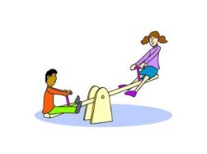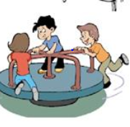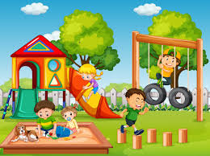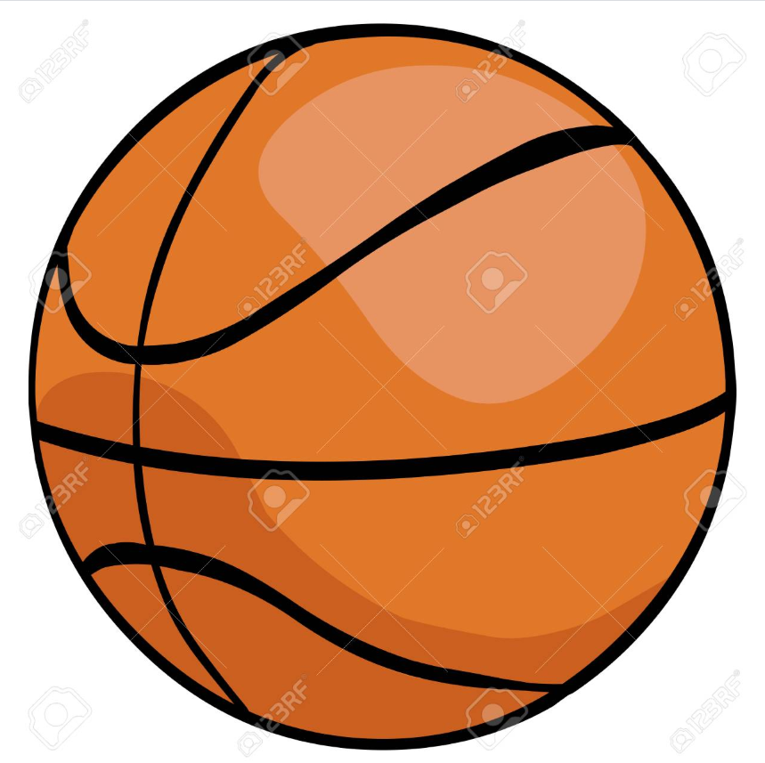

se __s __ __ me__ __y g__ a r__ __nd pl__ yg __ __und b__sk __t b__ll

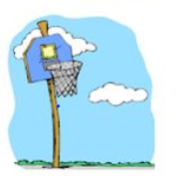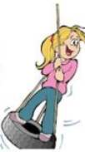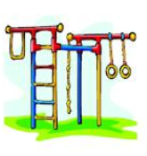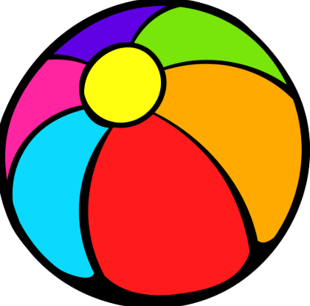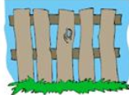

b__s __e__ h __ __p ti__ e s__ i__ __ cl__ mb__ng b__ __ b__ __l f__ __c __

2) Circle the correct answer.

a. The basketball /ball is orange.
c. The boy crosses the sand pit / bridge.
d. The parents / children play on the playground.

Answer key
- Slide, sand pit, bridge, monkey bar, seesaw, merry go around, playground, basketball, basket hoop, tire swing, climbing bar, ball, fence
- Ball, pit, children

