Name: ____________________________ Surname: ____________________________ N^{ber}: ____ Grade/Class: _____
Assessment: _____________________________  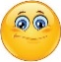 | Date: ___________________________________________________
 | Teacher’s signature:  ___________________________ | Parent’s signature:  ___________________________

1) Fill in the activity on the picture.

sliding | hopscotch | skating | running
swinging | skipping | seesaw | turning around

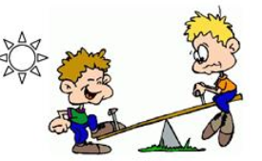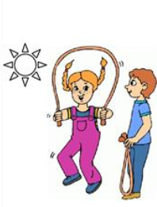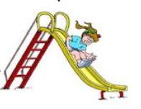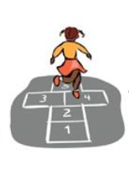

________ _______ _______ _______

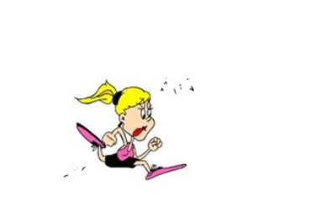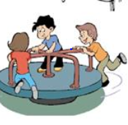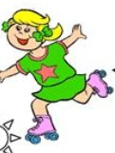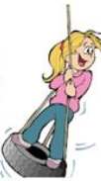

________ _______ _______ _______

2) Fill in the missing words.

a. The boy is sliding down the _______.

b. The girl is swinging on the _______.

c. The boys are sitting on the _______.

Answer key

- Seesaw, skipping, sliding, hopscotch, running, turning around, skating, swinging

- Slide, swing, seesaw

