Name: ____________________________ Surname: ____________________________ N^{ber}: ____ Grade/Class: _____
Assessment: _____________________________  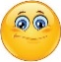 | Date: ___________________________________________________
 | Teacher’s signature:  ___________________________ | Parent’s signature:

1) Unscramble.

l a p y r g d n o u ___________________
l s i e d ___________________
w s i g n ___________________
s s e e a w ___________________
r n d o u b o u t a ____________________
n d a s i p t ____________________
m y o n k e r a b s ____________________

2) Label the pictures.

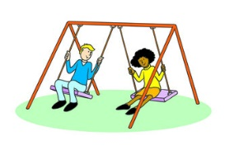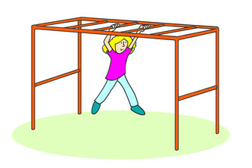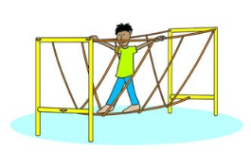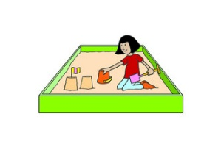

_________________ _________________ _________________ _________________
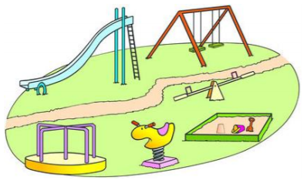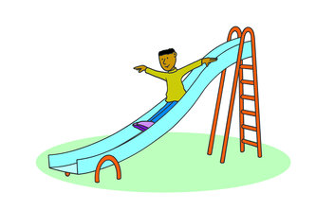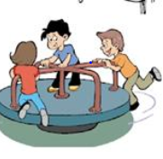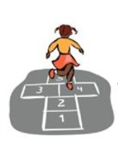
_________________ _________________ _________________ _________________

Answer key
- playground
slide
swing
seesaw
roundabout
sandpit
monkey bars

- swing
monkey bars
bridge
sand pit
playground
slide
roundabout
hopscotch

