Name: ____________________________ Surname: ____________________________ N^{ber}: ____ Grade/Class: _____
Assessment: _____________________________  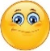 | Date: ___________________________________________________
 | Teacher’s signature:  ___________________________ | Parent’s signature:  ___________________________

1) Fill in the gaps.

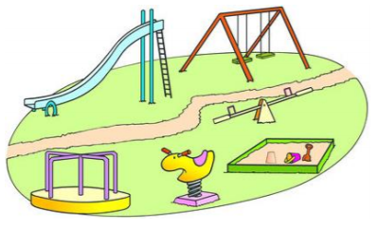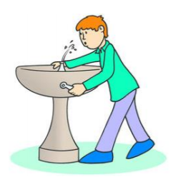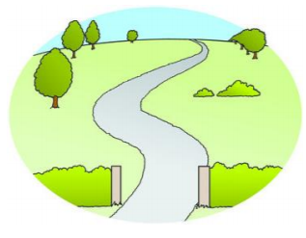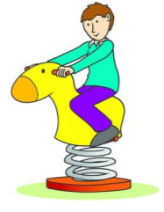
__la__ __r __ __ n__ __ __ i__ k__ __g __ __ un __ __in __a__k s__ __i n__y
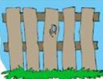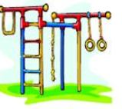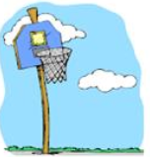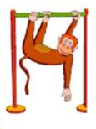
__en__e c__ __mb __ __g b__ __s b__s__ __t __ __op m__ __ __ __ __ b __ __s
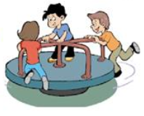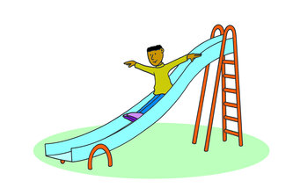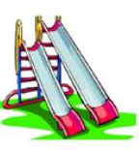

__ __ __ __ __ go __ __ u __ __ __ __ i __ __ __ __ i__ __s

2) Fill in the right activity.

swinging | sliding | Hopscotch | skipping

a. The girl is______________ the rope. b. The girl is ______________.
c. The boy is ______________ down the slide. d. The girl is playing ______________.
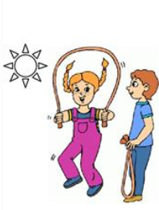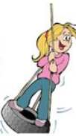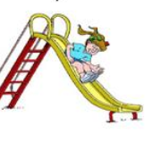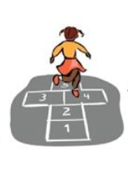

Answer key

- Playground
drinking fountain
park
springy
fence
climbing bars
basket hoop
monkey bars
merry go round
slide
slides

- Skipping
Swinging
Sliding
hopscotch

