Name: ____________________________ Surname: ____________________________ N^{ber}: ____ Grade/Class: _____
Assessment: _____________________________ | Date: ___________________________________________________
 | Teacher’s signature:  ___________________________ | Parent’s signature:  ___________________________

- Colour and write:
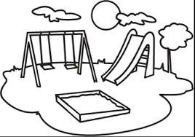
There is a s___________, a s_________ and ___________.
- Draw on the picture above:
- a kite ON the tree
- a ball UNDER the slide
- a ball IN the sand
Arrange the words in the correct order.
a) is / The / ball / net / in / the ____________________________________________
b) The / tree / is / kite / on / the ____________________________________________
c) The / tree / is / boy / under / the _____________________________________________
d) girl / The / is / next / the / to / boy _____________________________________________
Answer key
- Swing, slide and sand
- drawing
- The ball is in the net. The kite is on the tree. The boy is under the tree. The boy is next to the girl.

