Name: ____________________________ Surname: ____________________________ N^{ber}: ____ Grade/Class: _____
Assessment: _____________________________ | Date: ___________________________________________________
 | Teacher’s signature:  ___________________________ | Parent’s signature:  ___________________________

- Look at the pictures and write.
a b c d
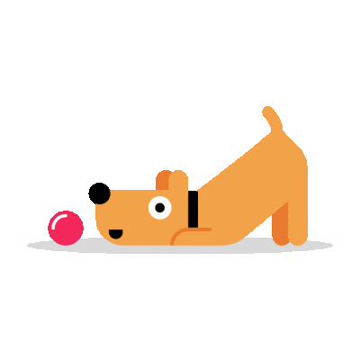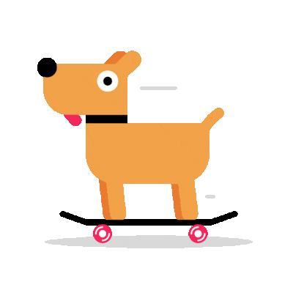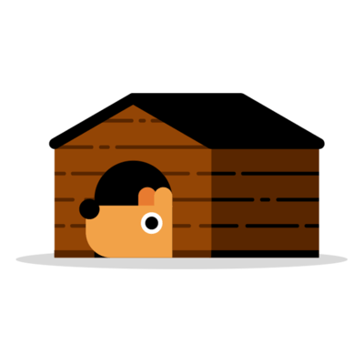
- The dog is next to the __________.
- The dog is on the ______________.
- The dog is in the _____________.
- The dog is next to the __________.
- Arrange the words.
- dog / the / in / house / the ____________________
- the / cat / to / next / is / dog ____________________
- dog / the / to / ball / next to / the ____________________
- skateboard / the / dog / on / is / the ___________________

Answer key
- The dog is next to the ball. The dog is on the skateboard. The dog is in the house. The dog is next to the cat.
- The dog is in the house. The dog is next to the cat. The dog is next to the ball. The dog is on the skateboard.

