Name: ____________________________ Surname: ____________________________ N^{ber}: ____ Grade/Class: _____
Assessment: _____________________________  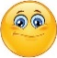 | Date: ___________________________________________________
 | Teacher’s signature:  ___________________________ | Parent’s signature:  ___________________________

- Write:
- The __________ is on the 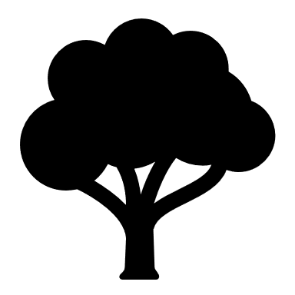______________
- The ____________ is next to the 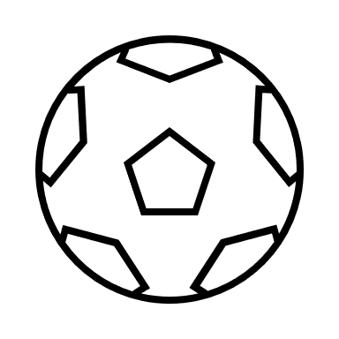_______________
- The 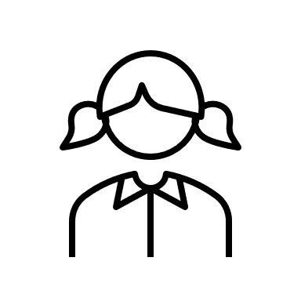_____________ is on the ___________________

- Arrange the words in the correct order.

a) The / kite / on / isn’t / the / sand ____________________________________

b) ball / is / The / seesaw / the / under ____________________________________
c) girl / The / isn’t / tree / to / next / the _____________________________________

Answer key
- A) kite, tree. B) seesaw, ball c) girl, seesaw
- A) The kite isn’t on the sand. B) The ball isn’t under the seesaw. C) The girl isn’t next to the tree.

