Name: ____________________________ Surname: ____________________________ N^{ber}: ____ Grade/Class: _____
Assessment: _____________________________ | Date: ___________________________________________________
 | Teacher’s signature:  ___________________________ | Parent’s signature:  ___________________________

- Colour and write.
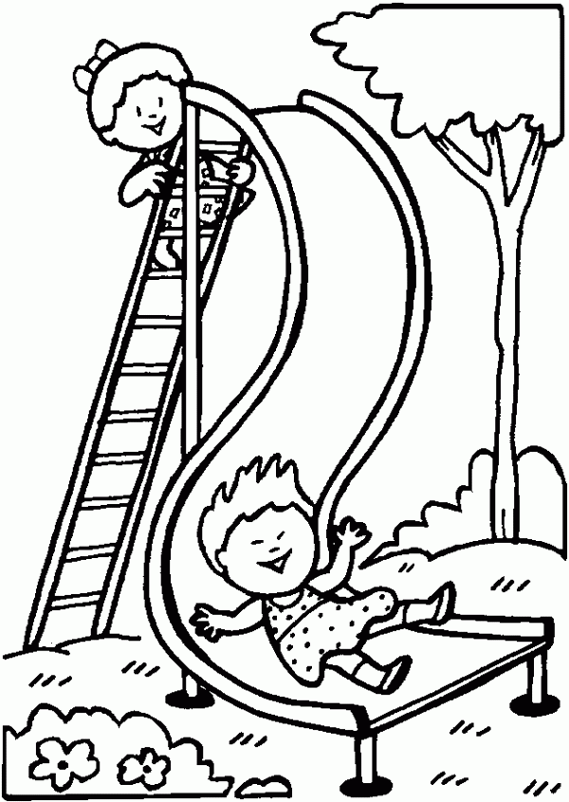
- The ____________ is on the s_________
- The s_____________ is next to the _____________

- Write correct punctuation.

- tom is in the playground ___________________________

- where is the ball ____________________________
- sally and marry are on the swing ___________________________

Answer key
- a) girl, slide b) slide, tree
- Tom is in the playground.
Where is the ball?
Sally and Marry are on the swing.

