Name: ____________________________ Surname: ____________________________ N^{ber}: ____ Grade/Class: _____
Assessment: _____________________________ | Date: ___________________________________________________
 | Teacher’s signature:  ___________________________ | Parent’s signature:  ___________________________

- Match and write.
The boy is…
The girls are …
The slide is…
The ball is…
…next to the swing.
…under the slide.
…on the slide.
…on the swing.

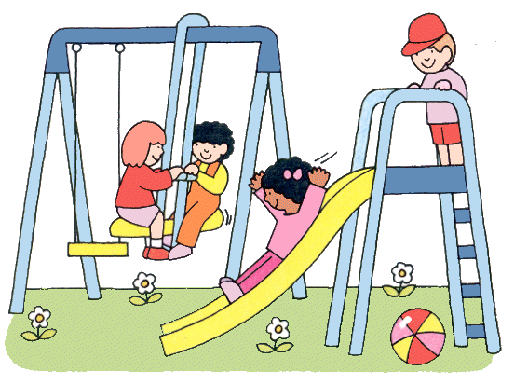

a) ____________________________________ b) ____________________________________

c) _____________________________________ d) _____________________________________

2) Arrange the words in the correct order.
a) Where / is / ball / the? ____________________________________________
b) kite / is / Where / the? ____________________________________________
c) boy / is/ Where / the? _____________________________________________

Answer key
- The boy is on the slide. The girls are on the swing. The ball is under the swing. The slide is next to the swing.
- Where is the ball? Where is the boy? Where is the kite?

