Name: ____________________________ Surname: ____________________________N^{ber}: ____ Grade/Class: _____
Assessment: _____________________________ | Date: ___________________________________________________
 | Teacher’s signature:  ___________________________ | Parent’s signature:  ___________________________

- Listen and Tick (✅) or Cross (❌)

 | 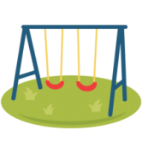 |  | 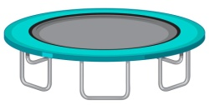 | 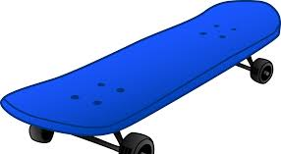 | 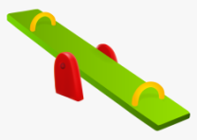
Kelly | ✅ |  | ❌
Peter
Danish
Ivanka

2) Listen and number.
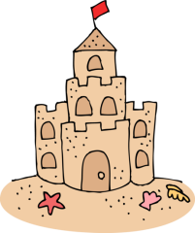
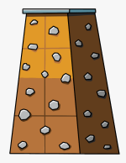

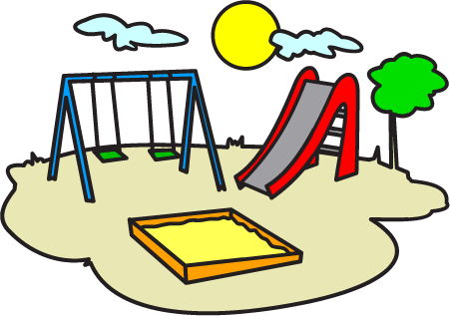

TRANSCRIPT

Exercise 1

- Kelly likes to play on the swing and she doesn’t like to jump on the trampoline.
- Peter likes to jump on the trampoline and skate, but he doesn’t like to play on the slide.
- Danish likes to play see-saw with his best friend.
- Ivanka dislikes to play on the slide, as she is scared of the slide. She likes to play on the swing.

EXERCISE 2

- See-saw
- Sand castle
- Playground
- Skateboard
- Swing
- Climbing rock wall
- Trampoline
- Slide

