Name: ____________________________ Surname: ____________________________N^{ber}: ____ Grade/Class: _____
Assessment: _____________________________ | Date: ___________________________________________________
 | Teacher’s signature:  ___________________________ | Parent’s signature:  ___________________________

- Listen and tick.

- Playing in the ________ is good excercise.
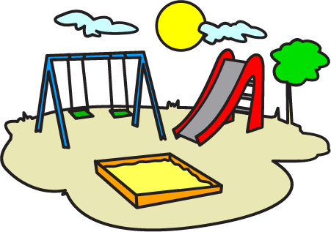
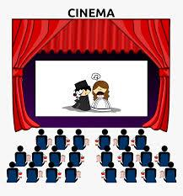

- All kids love going to the _______ or the playground.

- Children are ______ in the playground.
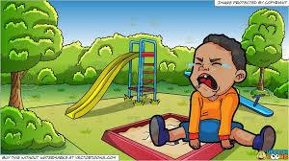
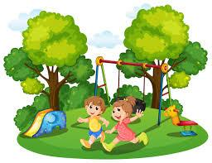

- Sam and Siya are playing on the _______.
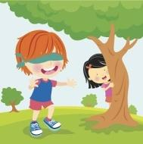
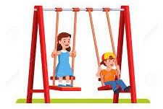

- “What does your swing sound like? A monkey? An Elephant? I hear it squeaking like a _____! It’s so squeaky.”

TRANSCRIPT

EXERCISE 1

Listen to the sentences and tick the option that is appropriate to fill up the blank in each sentence.
- Playing in the playground is good exercise.
- All kids love going to the park or the playground.
- Children are running in the playground.
- Sam and Siya are playing on the swing.
- “What does your swing sound like? A monkey? An Elephant? I hear it squeaking like a bird! It’s so squeaky.”

