Name: ____________________________ Surname: ____________________________N^{ber}: ____ Grade/Class: _____
Assessment: _____________________________ | Date: ___________________________________________________
 | Teacher’s signature:  ___________________________ | Parent’s signature:  ___________________________

- Listen and number.

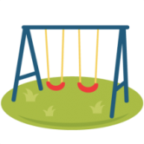
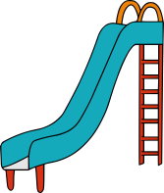

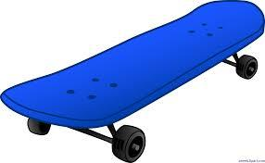

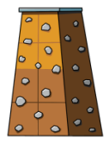
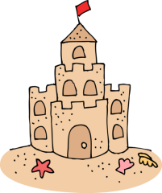

- Listen and color.
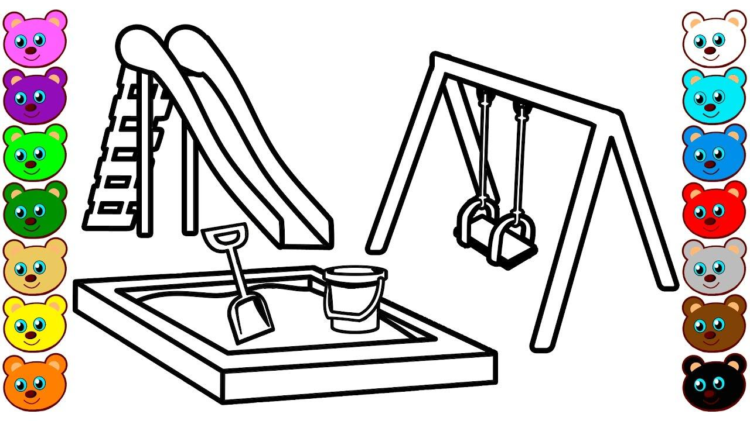

TRANSCRIPT

EXERCISE 1

Once upon a time there were four children. On a warm and sunny day the parents of each child took them to an adventure playground for a play.
- The first child had a wonderful time at the playground. He swung on the swings and slid on the slippery-slides.
- The second child played with the skateboard for a long time.
- The third child made a sand castle with her mother’s help.
- The fourth child climbed on the rock wall with his father’s support.

EXERCISE 2

Colour the following playground equipment with the mentioned colours.

- Sandpit – Brown
- Slide – Red
- Swing - Blue

