Name: ____________________________ Surname: ____________________________N^{ber}: ____ Grade/Class: _____
Assessment: _____________________________ | Date: ___________________________________________________
 | Teacher’s signature:  ___________________________ | Parent’s signature:  ___________________________
- Listen and write.
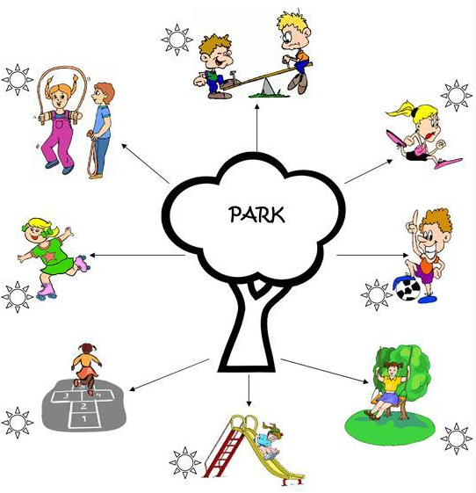

PLAYGROUND

TRANSCRIPT

EXERCISE 1

The children are playing in the playground. Write the names of the children according to the activities they are doing.

- Harry and Preeti are playing with the skipping rope.
- Michael is playing football.
- Heena is skating.
- Ronnie and Nobi are playing on the see-saw.
- Kelly is running in the playground.
- Suzie is playing hopscotch.
- Rita is playing on the slide.
- Jenny is playing on the swing.

