Name: ____________________________ Surname: ____________________________ N^{ber}: ____ Grade/Class: _____
Assessment: _____________________________  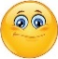 | Date: ___________________________________________________
 | Teacher’s signature:  ___________________________ | Parent’s signature:  ___________________________

- Read and draw.

Ben is in the playground.
The bench is under the tree.
The kite is on the bench.
The ball is in the sand.
Sally is in front of the swing.

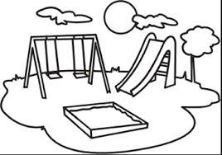

- Read the text again and correct the mistakes in the underlined words.
- Nathan is in the playground.
- The ball is under the tree.
- The kite is in the sand.
- Sally is in front of the slide.

Answer key

1. drawing
2. a- Ben; b-bench; c-ball; d-swing.

