Name: ____________________________ Surname: ____________________________ N^{ber}: ____ Grade/Class: _____
Assessment: _____________________________  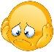 | Date: ___________________________________________________
 | Teacher’s signature:  ___________________________ | Parent’s signature:  ___________________________

- Read and write numbers.

1. Spike likes to play. First, he rides a skateboard.
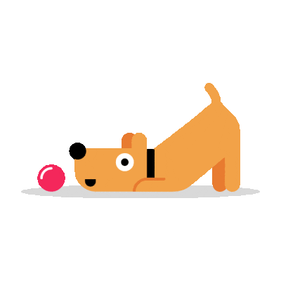
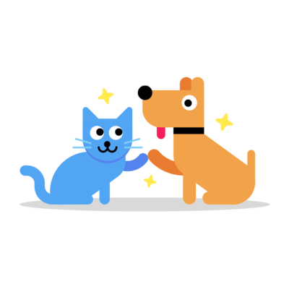
3. Then Spike plays with the cat. Spike is next to the cat.

2. Then Spike plays with a ball. In the picture, he is next to the ball.

a) ____________
b) ____________
c) ____________
d) ____________

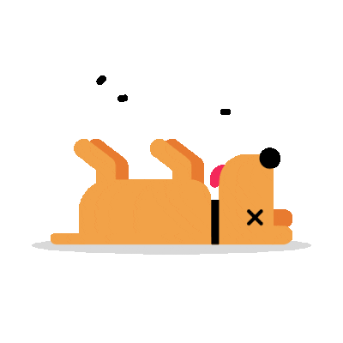
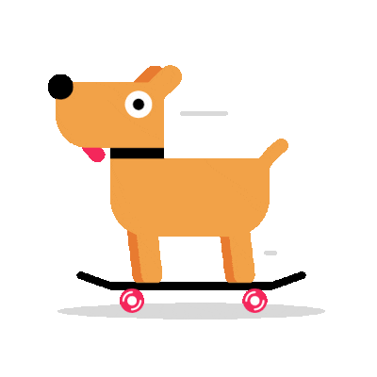
4. After playground Spike is tired. He is on the ground.

2) Read and circle.

Hello, I am James. I like to play in the playground / house. I like to ride skateboard / bike. My dog Spike likes skateboard / bike too.
Spike plays with the ball / kite too.

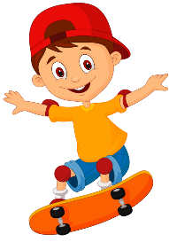

Answer key

- A-2; b-3; c-1; d-4.

- Playground, skateboard, skateboard, ball.

