Name: ____________________________ Surname: ____________________________ N^{ber}: ____ Grade/Class: _____
Assessment: _____________________________ | Date: ___________________________________________________
 | Teacher’s signature:  ___________________________ | Parent’s signature:  ___________________________

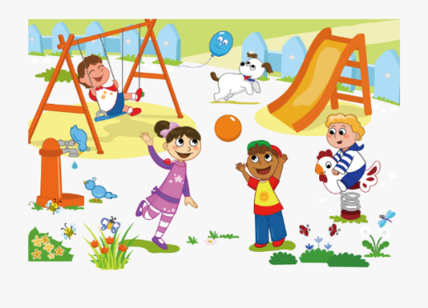
- Look, read and write Yes or No.

The boy is on the slide. ___________

The girl is on the swing. ___________

The dog is next to the slide. ___________

There are four children in the playground. ___________

- Look again, read and link.
The girl is next to the
playground.
1) A

The boy is on the
2) B

boy in yellow T-shirt.

3) C

swing.
The dog is next to the

4) D

slide.
The children are in the

Answer key

- No, no, yes, yes.

- 1-b; 2-c; 3-d; 4-a.

