Name: ____________________________ Surname: ____________________________ N^{ber}: ____ Grade/Class: _____
Assessment: _____________________________ | Date: ___________________________________________________
 | Teacher’s signature:  ___________________________ | Parent’s signature:  ___________________________
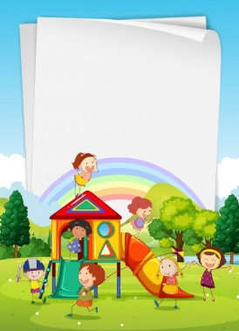

- Read and match.
The children are in the playground.
The ball is in the net. The seesaw is on the grass.
The kite is on the tree. The swing is under the tree.
The children are next to the slide.

…the tree.
…the slide.
…the tree.
…the net.
…under…
..next to…
…in…
…on…
The children are…
The ball is…
The kite is…
The swing is…

- Read again and write Yes or No.
- The ball is in the net.
- The kite is under the tree.
- The seesaw is under the tree.
- The slide is on the grass.
Answer key
- The children are next to the slide.
The ball is in the net.
The kite is on the tree.
The seesaw is under the tree.

- a) Yes; b) No; c) Yes; d) No.

